**Get A DOMAIN NAME**

Sign into heartland-webhosting.com <https://heartland-webhosting.com/>

From the opening screen click “Registered Domain”

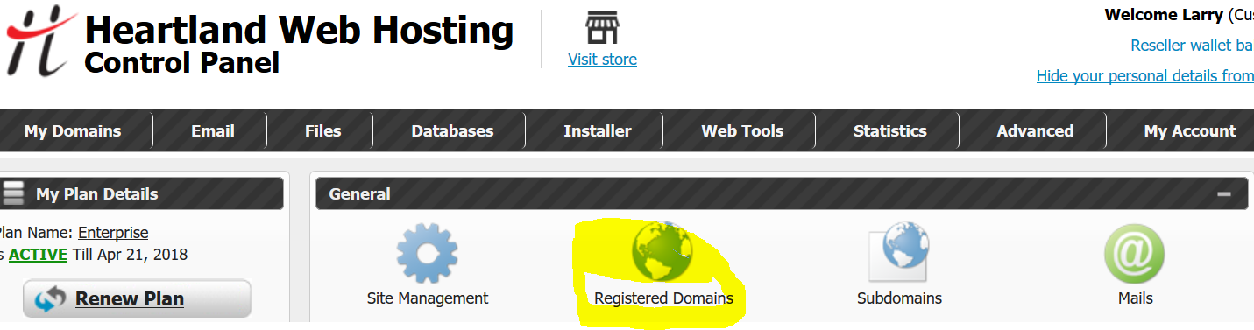

Next Page click “Register Domain”

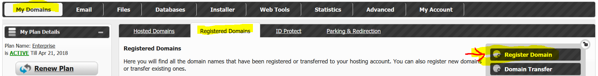

Type in the domain name and extension you want and click “Check”

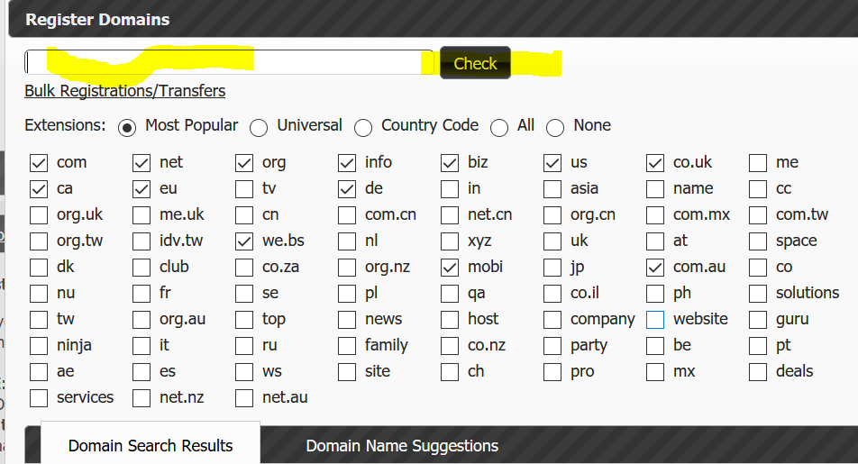

I put in larryhall.info in the blank as a domain I would like.

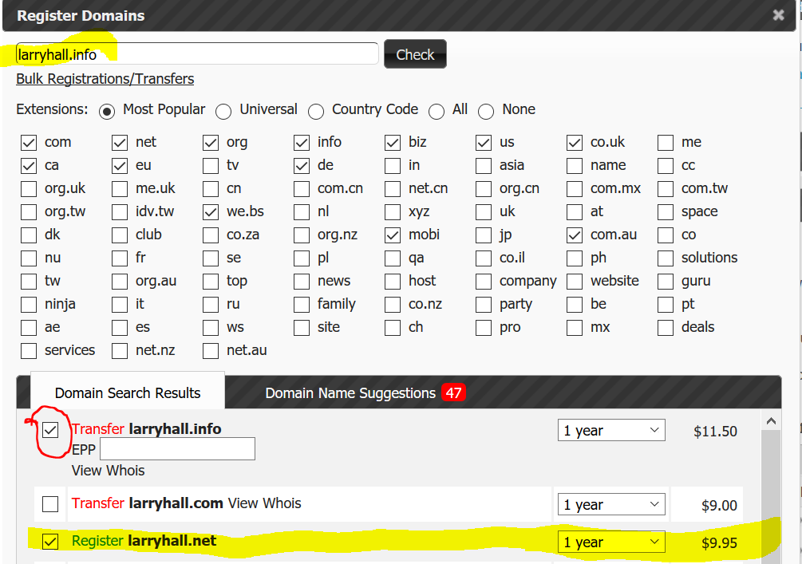

**Problem**! The choice came up Transfer. Which means somebody already owns that domain. You would use this to transfer a domain from one host provider to another.

You must **uncheck** the Transfer and Check the **Register** box on the name with a different extension. The alternative is to pick a different name.

**Make sure you only have *one box* is checked! When you click “Continue” on the bottom of the page you are buying *all* that are checked.**

I picked larryhall.net and pressed “Continue”.

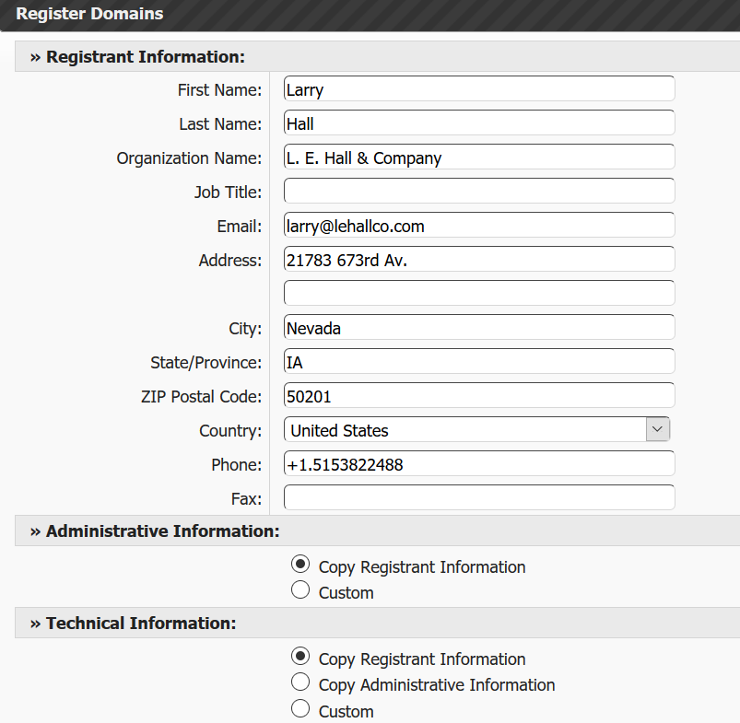

Check the “REGISTRANT INFORMATION” for accuracy. Leave the other three “Information” buttons “Copy Registrant Information” checked. Also, leave the “Nameserver Box” checked.

Click “Payment”

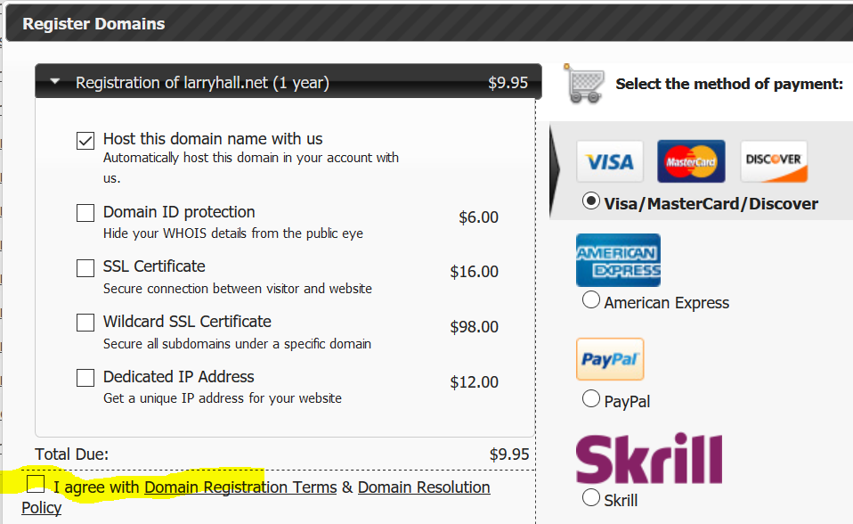

Check the “I agree” box and select how you would like to pay for your domain.

NOTE:

1. “Heartland Web Hosting” is in association with LiquidNet Ltd. Which is registered in the United Kingdom, Registration No. 4654498.As a result, 'WEB HOSTING' or 'HOSTING AND DOMAINS' will show up on your credit card statement.

**Prior to using your Credit Card, you should notify your** **Credit Card Company that you are make this charge.**

1. Spammers follow newly registered Domain names. YOU may get annoying emails, texts and/or phone calls to sell you services. **NONE** of them are from Heartland. You do NOT need their services and they are **not** to be trusted. Nothing can be done to stop this. Just Black list, send them to spam, and /or set their number to block.